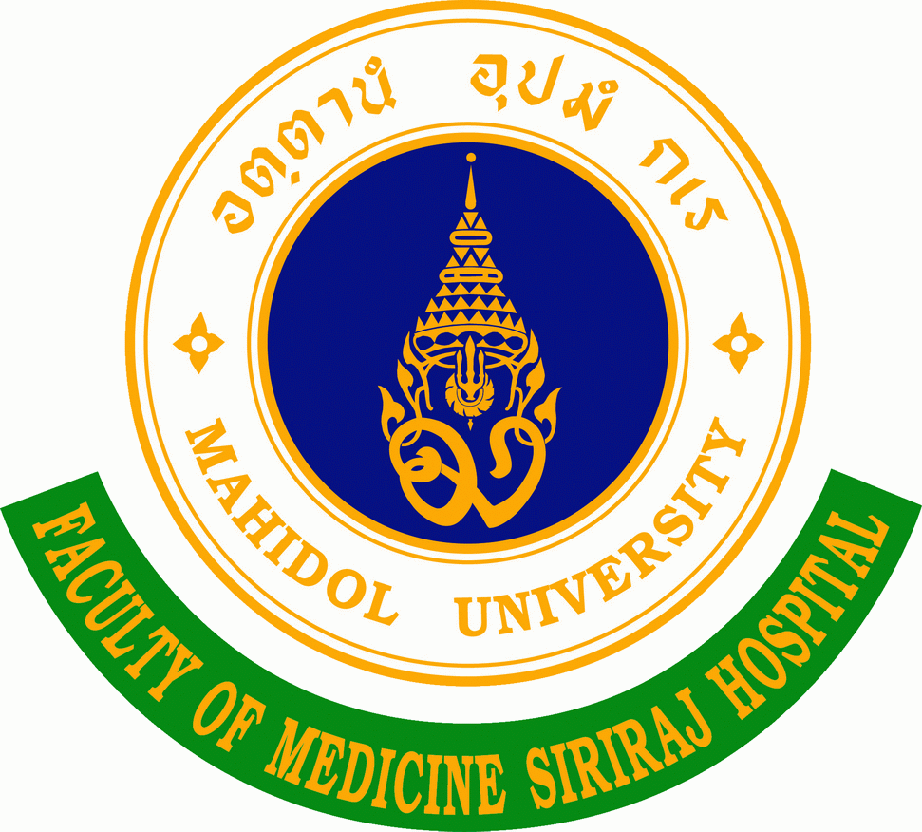
Recent photo within 6 months

APPLICATION FORM 2020
FELLOWSHIP IN CLINICAL PAIN MANAGEMENT
SIRIRAJ CLINICAL PAIN MANAGEMENT TRAINING CENTER

This form must be completed in order to apply for the training program and the required attachments (see item 7) must be submitted at the time of submission of application. Use as much space as necessary within each box for the information requested. This application and attachments should be mailed (via e-mail, fax, or airmail) to Siriraj Clinical Pain Management Training Center, Mahidol University at the address below. Please read the enclosed guidelines carefully.
Mailing Si-CPM Training Center Secretariat
Address: Siriraj Clinical Pain Management Training Center, Department of Anesthesiology,
Faculty of Medicine Siriraj Hospital, Mahidol University
2 Prannok Rd, Bangkoknoi, Bangkok 10700 THAILAND
Tel: +66-2419-9465
Fax: +66-2418-1621
Email: irsiriraj@gmail.com

(Please complete form on your computer and use as much space as necessary within each box)
Name of Applicant
(include professional degrees)
Gender  Birthday  Birthplace  Nationality | Male Female  // DD/MM/YYYY  ………………………………………………..  ………………………………………………..
Current Professional Affiliation (e.g., name of university, institute, hospital)
Specialty and subspecialty (with graduated year)
Mailing address
Telephone
Mobile
Fax
email
Applying for | 3 month-program 1 year-pain fellowship training program
I am the member of IASP/WFSA | No yes
I have medical problems | No yes, state the details.
Please supply detailed information under the following headings
(use as much space as necessary within each box)
1. Reason why you select clinical pain management for your training.

2. Please outline your working and training experiences: your responsibilities, specialization, and how much/ in which way will these be pertinent to the practice on Pain? Have you ever been trained in pain management before, how long?

3. Objectives of the training. How can this training program accomplishment be value to your clinical work?

4. How can this training program accomplishment be value to your working institute?

5. Details of your working place and barriers, for example, nature of sites (clinic or hospital), number of beds in the hospital, the resources that are available such as the essential drugs, the collaboration team: nurses, psychiatrist, rehabilitation, anesthetist etc.

6. Do you anticipate any difficulties during your training program? How does the Time sequence of the program, i.e. a year, affect to your family / medical income at home?

7. Other relevant information (use additional space if necessary)
8. Attachment of following applicant’s information are required :
curriculum vitae with 1 recent photo
Doctor of Medicine Certificates
Board Certificate (either in Anesthesiology or Rehabilitation Medicine )
Two letters of recommendation ( one of them should be from trainee’s institution states that he/she has served as their clinical staff and will be potentially supported in the career)
9. Signature of Applicant: (typed name is acceptable if application is transmitted by email) |  | Date:

